** MACHINERY TOOL HEALTH MONITORING**

**AND**

**LIFE PREDICTION**

A MINI PROJECT REPORT

Submitted by

ABHINESH.M 1501002

ARVIND.M 1501019

BALAGANESH.S 1501022

JANARTHANAN.I 1501055

in partial fulfilment for the award of the degree

of

BACHELOR OF ENGINEERING

in

COMPUTER SCIENCE AND ENGINEERING

**SRI RAMAKRISHNA ENGINEERING COLLEGE**

[Educational Service: SNR Sons Charitable Trust]

[Autonomous Institution, Accredited by NAAC with ‘A’ Grade]

[Approved by AICTE and Permanently Affiliated to Anna University, Chennai]

[ISO 9001:2008 Certified and All Eligible Programmes Accredited by NBA]

Vattamalaipalayam, N.G.G.O. Colony Post,

**COIMBATORE – 641 022**

**ANNA UNIVERSITY: CHENNAI 600 025**

**APRIL 2018**

**SRI RAMAKRISHNA ENGINEERING COLLEGE**

**COIMBATORE-641022**

BONAFIDE CERTIFICATE

Certified that this Mini Project Report, “**MACHINERY TOOL HEALTH MONITORING AND LIFE PREDICTION**” is the bonafide work of

ABHINESH.M 1501002

ARVIND.M 1501019

BALAGANESH.S 1501022

JANARTHANAN.I 1501055

who carried out the project work under my supervision.

**SIGNATURE SIGNATURE**

**Dr. M.S. GEETHA DEVASENA Dr. A. GRACE SELVARANI**

**SUPERVISOR HEAD OF THE DEPARTMENT**

**Professor** **Professor**

Department of Computer Department of Computer

Science and Engineering, Science and Engineering,

Sri Ramakrishna Engineering College, Sri Ramakrishna Engineering College,

Coimbatore- 641 022. Coimbatore- 641 022.

Submitted for the University viva-voce examination held on ____________________________

Internal Examiner External examiner

DECLARATION

We affirm that the project work titled “**MACHINERY TOOL HEALTH MONITORING AND LIFE PREDICTION**” being submitted in partial fulfilment for the award of Bachelor of Engineering is the original work carried out by us. It has not formed the part of any other project work submitted for award of any degree or diploma, either in this or any other University



I certify that the declaration made above by the candidate is true.

---------------------------------- -------------------

(Signature of the Candidates)

Name Roll

ABHINESH.M 1501002

ARVIND.M 1501019

BALAGANESH.S 1501022

JANARTHANAN.I 1501055

-------------------------------

**Dr.M.S.Geetha Devasena**

**Professor  
 Department of CSE.**

ACKNOWLEDGEMENT

First and foremost, we would like to thank our Managing Trustee, **Sri. R.VIJAYAKUMHAR, M.S., MBA** and Joint Managing Trustee, **Sri,** **D.LAKSHMI NARAYANASAMY, B.Tech., MBA.,** SNR Sons Charitable Trust, Coimbatore for providing us excellent facilities to work on our project.

We express our profound and sincere thanks to **Dr. A. EBENEZER JEYAKUMAR, M.E., Ph.D.,** Director (Academics) for his kind patronage, which helped for carrying out this project.

With profound respect, we would like to express our sincere thanks to our Principal, **Dr. N. R. ALAMELU, M.E., Ph.D.,** Principal, for provoking us with this wonderful opportunity for carrying out this project.

We would like to express our deepest gratitude to **Dr. A. GRACE SELVARANI, M.E., Ph.D.,**  Head of the Department, Department of Computer Science and Engineering, for her constant support and motivation.

We sincerely thank our Project Coordinator, **Dr. R. MADHUMATHI, M.E., PhD.,** Assistant Professor(SL Grade), Department of Computer Science and Engineering for her great inspiration.

We extend our heartfelt thanks to our project guide, **Dr. M.S.GEETHA DEVASENA, M.E., Ph.D.,** Professor, Department of Computer Science and Engineering, for the guidance and support throughout this project work and who makes this project a successful one.

ABSTRACT

Machine health monitoring is necessary in today’s automated industry world. The existing health monitoring systems analyses the condition and working of the machines to an accurate rate. The proposed system analyses the condition and working of the machine along with the prediction of the lifetime of the machinery, thus, providing an upper hand in the automated world. The lifetime forecasting is done by implementing predictive analysis which uses linear regression algorithms consisting of vibration, temperature and humidity data gathered through suitable vibration and temperature sensors. The proposed system identifies fault occurring conditions at an accurate rate in the earlier stages itself which makes it easier to adapt with the predicted results. This succeeds in monitoring the health of the machine in the automated world without interrupting the general working of machineries.

i

TABLE OF CONTENTS

CHAPTER TITLE PAGE

NO. NO.

ABSTRACT i

LIST OF FIGURES iv

1. INTRODUCTION

1.1 Embedded Systems 1

1.2 Data Analytics 1

1.3 Machine Monitoring Concept 2

1.4 Advantages of Machine Monitoring 2

2. LITERATURE SURVEY

2.1 Condition monitoring and fault diagnosis 3

2.2 Sensor signal segmentation for tool condition monitoring 3

2.3 Analyzing RMS and peak values of vibration signals 3

for condition monitoring of wind turbine gearboxes

3. SYSTEM ANALYSIS

3.1 Existing System 4

3.2 Proposed System 4

4. SYSTEM SPECIFICATION

4.1 Hardware Requirements 5

4.2 Software Requirements 5

5. HARDWARE DESCRIPTION 6

6. SOFTWARE DESCRIPTION 7

7. PROJECT DESCRIPTION

7.1 Problem Definition 9

7.2 Overview 9

7.3 System Architecture 10

7.4 Module Description 12

7.5 Input and Output Design 14

ii

8. SYSTEM IMPLEMENTATION 15

9. CONCLUSION AND FUTURE IMPLEMENTATION

9.1 Conclusion 17

9.2 Future Implementation 17

10. APPENDIX

10.1 Source code and Screenshots 18

10.2 Reference 25

iii

LIST OF FIGURES

|  |  |  |
| --- | --- | --- |
| FIGURE NO | NAME OF THE FIGURES | PAGE NUMBER |
| 1 | Flow Diagram of Machine Health Monitoring | 11 |

iv

CHAPTER 1

INTRODUCTION

1.1 EMBEDDED SYSTEMS

Embedded systems are computing systems, but can range from having no [user interface (UI)](http://searchmicroservices.techtarget.com/definition/user-interface-UI) for example, on devices in which the embedded system is designed to perform a single task to complex [graphical user interfaces (GUI)](http://searchwindevelopment.techtarget.com/definition/GUI), such as in mobile devices. User interfaces can include buttons, LEDs, touch screen sensing and more. Some systems use remote user interfaces as well.

An embedded system is basically an electronic system that can be programmed or non-programmed to operate, organize, and perform single or multiple tasks based on the application. In the real time embedded systems, all the assembled units work together based on the program or set of rules or code embedded into the microcontroller. But, by using this [microcontroller programming techniques](https://www.elprocus.com/ds1307-rtc-interfacing-with-8051-microcontroller/) only a limited range of problems can be solved.

1.2 DATA ANALYTICS

Data Analytics (DA) is the process of examining [data](http://searchdatamanagement.techtarget.com/definition/data) sets in order to draw conclusions about the information they contain, increasingly with the aid of specialized systems and software. Data analytics technologies and techniques are widely used in commercial industries to enable organizations to make more-informed business decisions and by scientists and researchers to verify or disprove scientific models, theories and hypothesis.

1.3 MACHINE MONITORING CONCEPT

Vibration analysis for monitoring the condition of machinery and determining the faults in their early stages. The patterns are analysed and the corresponding life time is forecasted with maximum accuracy. Condition monitoring is the process of monitoring a parameter of condition in machinery, such that a significant change is indicative of a developing failure. During operation, machine parts are subjected to fatigue, wear, deformation and foundation settlement. When faults begin to develop some of dynamical processes in the machine are changed influencing vibrations produced by the machine.

* 1. **ADVANTAGES OF MACHINE MONITORING**

It is capable of detecting, locating and distinguishing faults, it is non-destructive technique, data can be acquired during normal machinery operation.

* Analysis techniques together with the advent of miniature vibration sensors and high-speed data acquisition technologies provide a unique opportunity to develop and implement, beneficent, and non-intrusive condition monitoring and quality assessment methods for a broad range of rotating machineries.
* The acquiesced data from the rotating machinery is then pre-processed with the data cleaning techniques. Then the cleaned data is then forecasted using data analysis tool and the health of the machinery is predicted.

CHAPTER 2

**LITERATURE SURVEY**

2.1 Vladimir Dekys, **Condition monitoring and fault diagnosis**

The paper discusses the problem detection of vibration source, transfer path and modal properties of analyzed object. Some selected signal processing techniques were presented in the field of machine monitoring on the basis of vibration. These procedures are also useful in solving scientific and research challenges in reducing or correcting noise and vibration.

**MERITS**

* Detection of sources of vibration will be made based on the amplitude spectra and phase relationships of vibrations of individual machine parts
* Multi-parameter approach

**DEMERITS**

* The process of noise correction is tedious
* No prediction analysis

2.2 Sebastian Bombinski, Krzysztof Blazejak, Miroslaw Nejman Krzysztof Jemielniaka, **Sensor signal segmentation for tool condition monitoring**

The paper presents algorithms for automatic selection of short, steady state, representative signal segments. The algorithms allow detection of cutting based on all available signals using their low pass filtered values and standard deviation as signal features..

**MERITS**

* Non-parametric Methods : Normal Distribution using Kruskall-Wallis Tests
* Threshold values are calculated automatically, without user involvement.

**DEMERITS**

* Vibration classifications are not provided.
* No prediction analysis

2. 3 Joel Igba , Kazem Alemzadeh , Christopher Durugbo , Egill Thor Eiriksson, **Analyzing RMS and peak values of vibration signals for condition monitoring of wind turbine gearboxes**

This paper had made the case for the use of peak and RMS values of vibration signals for the CM of WT gearboxes. The CM data used in this study have been from high speed modules of gearboxes.

**MERITS**

* Use of peak and RMS values of vibration signals
* 3D Plotting

**DEMERITS**

* Results derived using peak and RMS values are not accurate
* No prediction analysis.

CHAPTER 3

SYSTEM ANALYSIS

3. 1 EXISTING SYSTEM

The vibration patterns of the machinery tools are recognized and analysed in the previous framework, in the process of channelling energy into job to be performed all machines vibrate. Machines rarely break down without giving some previous warning. The signs of impeding failure are generally present long before a machine totally breaks down. When faults begin to develop in the machine, some of dynamic processes in the machine are changed as well, thereby influencing machine vibration level, temporal and spectral vibration properties. Such changes can act as an indicator for early detection and identification of condition where the machine would fail.

3.2 PROPOSED SYSTEM

Analysis techniques together with the advent of miniature vibration sensors and high-speed data acquisition technologies provide a unique opportunity to develop and implement, beneficent, and non-intrusive condition monitoring and quality assessment methods for a broad range of rotating machineries.

The acquiesced data from the rotating machinery is then pre-processed with the data cleaning techniques. Then the cleaned data is then forecasted using data analysis tool and the health of the machinery is predicted. On the basis of this existing frame work, we analyse the vibration pattern ,pre-process the data and use it for prediction with accuracy.

CHAPTER 4

SYSTEM SPECIFICATION

4.1 HARDWARE REQUIREMENTS

* Arduino UNO
* ADXL335 Accelerometer
* Piezo-electric sensor
* DHT11Sensor

4.2 SOFTWARE REQUIREMENTS

* Arduino 1.0
* RStudio
* Parallax Data Acquisition tool (PLX-DAQ)

CHAPTER 5

HARDWARE DESCRIPTION

**ADXL335 ACCELEROMETER**

ADXL335 is accelerometer sensor which works on the principle of Piezoelectric effect. whenever we will tilt the sensor the ball is supposed to move in that direction because of Gravitational force. The walls are made of Piezoelectric elements. So, every time ball is touching the wall an electric current will be produced which will be interpreted in the form of values in any 3D space. ADXl335 is a triple axis accelerometer i.e. it will give 3 values in output. BW is adjustable as it has single capacitor per axis. Analog interfacing is done for communicating with other devices like Arduino.

**PIEZOELECTRIC SENSOR**

A piezoelectric sensor is a device that uses the piezoelectric effect, to measure changes in pressure, acceleration, temperature, strain, or force by converting them to an electrical charge.

**DHT11 SENSOR**

DHT11 is a Humidity and Temperature Sensor, which generates calibrated digital output. DHT11 can be interface with any microcontroller like Arduino, Raspberry Pi, etc. and get instantaneous results.DHT11 is a low cost humidity and temperature sensor which provides high reliability and long term stability.

CHAPTER 6

SOFTWARE DESCRIPTION

ARDUINO

Arduino refers to an open-source electronics platform or board and the software used to program it. Arduino is designed to make electronics more accessible to artists, designers, hobbyists and anyone interested in creating interactive objects or environments. An Arduino board can be purchased pre-assembled or, because the hardware design is open source, built by hand. Either way, users can adapt the boards to their needs, as well as update and distribute their own versions. In essence, Arduino provides a way to build and program electronics components.

**RSTUDIO**

**RSTUDIO** is a free and open source integrated development IDE for R, a open source programming language and software environment for statistical computing and graphics that is supported by the **R** Foundation for Statistical Computing. Polls, surveys of data miners, and studies of scholarly literature databases show that R's popularity has increased substantially in recent years.

R is a GNU package. The source code for the R software environment is written primarily in C, FORTRAN, and uses Qt framework for its graphical user interface. R is freely available under the GNU General Public License, and pre-compiled binary versions are provided for various operating systems. While R has a command line interface, there are several graphical front-ends available.

**PLX-DAQ**

Parallax Data Acquisition tool (PLX-DAQ) software add-in for Microsoft Excel acquires up to 26 channels of data from any Parallax microcontrollers and drops the numbers into columns as they arrive. PLX-DAQ provides easy spreadsheet analysis of data collected in the field, laboratory analysis of sensors and real-time equipment monitoring.PLX-DAQ is a Parallax microcontroller data acquisition add-on tool for Microsoft Excel. Any of our microcontrollers connected to any sensor and the serial port of a PC can now send data directly into Excel.

PLX-DAQ has the following features:

* Plot or graph data as it arrives in real-time using Microsoft Excel.
* Record up to 26 columns of data.
* Mark data with real-time (hh:mm:ss) or seconds since reset.
* Read/Write any cell on a worksheet.
* Read/Set any of 4 checkboxes on control the interface.
* Example code for the BS2, SX (SX/B) and Propeller available.
* Baud rates up to 128K.
* Supports Com1-15.

CHAPTER 7

PROJECT DESCRIPTION

7.1 PROBLEM DEFINITION

Understanding the problem is important to ensure interventions are based on intelligence rather than assumptions, professional opinions or limited knowledge. Developing solutions to Machinery related problems (such as lifetime, tool-wearing ,etc) is more effective when based on a variety of intelligence sources

7.2 OVERVIEW

Condition monitoring is the process of monitoring a parameter of condition in machinery, such that a significant change is indicative of a developing failure. During operation, machine parts are subjected to fatigue, wear, deformation and foundation settlement. When faults begin to develop some of dynamical processes in the machine are changed influencing vibrations produced by the machine. After the process of vibration analysis, the patterns are analysed and the acquired data is pre-processed using data cleaning techniques. The pre-processed data is then forecasted and the life time of the machinery tool is predicted.

The Data set is given as input in CSV (Comma Separated Values) format. The Data set contains various fields such as Date, Time, Sensor Reading, X reading, Y reading, Z reading, Temperature, Humidity, etc. Once the regression values are computed using linear model function keeping Product priority as dependent variable it can be used for prediction for a given date. In statistical modelling, **regression analysis** is a statistical process for estimating the relationships among variables. It includes many techniques for modeling and analyzing several variables, when the focus is on the relationship between a dependent variable and one or more independent variables (or 'predictors').

More specifically, regression analysis helps one understand how the typical value of the dependent variable (or 'criterion variable') changes when any one of the independent variables is varied, while the other independent variables are held fixed.

Most commonly, regression analysis estimates the conditional expectation of the dependent variable given the independent variables, the average value of the dependent variable when the independent variables are fixed. Less commonly, the focus is on a quoted location parameter of the conditional distribution of the dependent variable given the independent variables. In all cases, the estimation target is a function of the independent variables called the regression function.

7.3 FLOW DIAGRAM OF PROPOSED SYSTEM

The design flow of the project commences with the collection and compilation of dataset from two types of machineries, say, a normal and an abnormal machine. The datasets are verified for its noisy data and missing values. The datasets are then pre-processed. Classification of vibrations has been made when it has to be verified for noisy data and non-continuous human made vibration. The datasets are analysed corresponding to the threshold values. The regression technique has been carried out on multiple attributes of the dataset. The prediction of health status of a machine has been made.

Machinery Data Acquisition by Sensors

Data pre-processing

Analysis of Dataset

by Threshold values

Observed vs.

Predicted Data

Result Analysis

Fig 7.3 Flow Diagram of Machine Health Monitoring

**7.4 MODULE DESCRIPTION**

The overall proposed system is classified into three modules

* Data collection & Pre-processing
* Clustering & Prediction by Linear Regression
* Result Analysis
  + 1. **DATA COLLECTION & PRE-PROCESSING**
* Data set used in this problem is a real time data that consists of both numerical and categorical data.
* Data is pre-processed manually to find if there is any missing value(NA) or Impossible values(NAN)
* Non-continuous human made vibrations are neglected
* The Regression analysis to create models which describe the effect of variation in predictor variables on the response variable.
* The various parameters are read from the file and is passed to the function If the dataset contains some noise then it is repaired using mining techniques.
  + 1. **CLUSTERING & PREDICTION**

From the dataset the Sensor reading, Time, Humidity and temperatures are read and they are passed to a function. In this method linear regression algorithm is applied to predict the values. The packages used are Predict, Linear model and Ggplot. The co-efficient for the linear regression model

With parameters such as sensor reading and temperature are as follows.

* The regression intercept is 30.782738, and the regression value is0.025661

The co-efficient and error value for the multiple parameter linear regression dependent on parameters such as time, sensor reading, temperature and humidity are as follows

* Multiple R-squared: 0.9178, Adjusted R-squared: 0.7341
* F-statistic: 4.996 on 76 and 34 DF, p-value: 8.583e-07

**7.4.3 RESULT ANALYSIS**

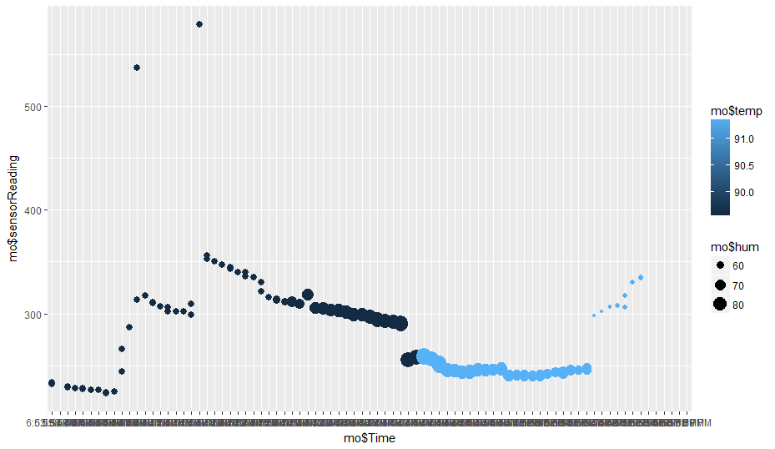

**Sensor Reading vs Time influenced by Temperature and Humidity**

The multiple parameter dependent linear regression clearly explains the corresponding plot sensor reading value with respect to time, temperature and humidity. The dot size explains the humidity value and this humidity is one of the major factor which portrays the fault condition when the threshold limit is reached. The colour intensity of the plot describes the temperature value and this intensity grows lighter when the temperature reading increases.

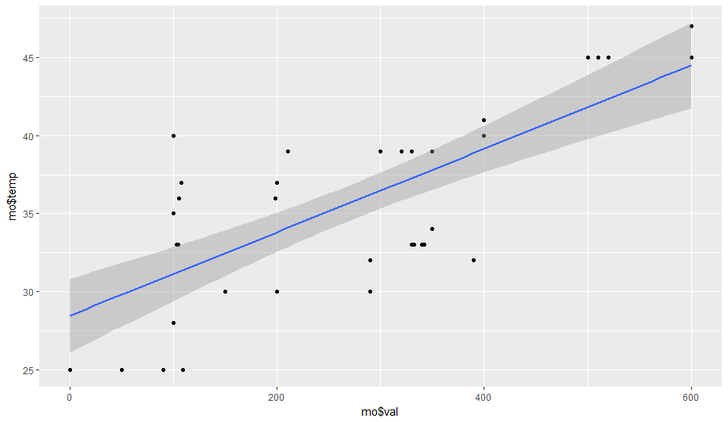

**Sensor value vs temperature plot in worn out condition**

This depicts the plot of sensor value versus temperature in worn out condition. The plot helps us to distinguish between normal running and abnormal condition. This does not clearly coincide with the intercept and error value and tends to denote the fault occurring state and in this stage there must be a maintenance call to avoid future break downs

**CHAPTER 8**

**SYSTEM IMPLEMENTATION**

The Machinery Tool Health Monitoring and Life Predictionis an application built using R Studio that helps us to analyze the machine vibration information and to predict the health status for a machine.

**8.1 DATA COLLECTION AND PRE-PROCESSING**

The Data set acts as the base for the whole prediction process to move forward. It is the data set from where we receive information about the vibrations. Also certain categorical data needs to be pre-processed to the corresponding numerical data for operations to be carried out. The attributes in the dataset are:

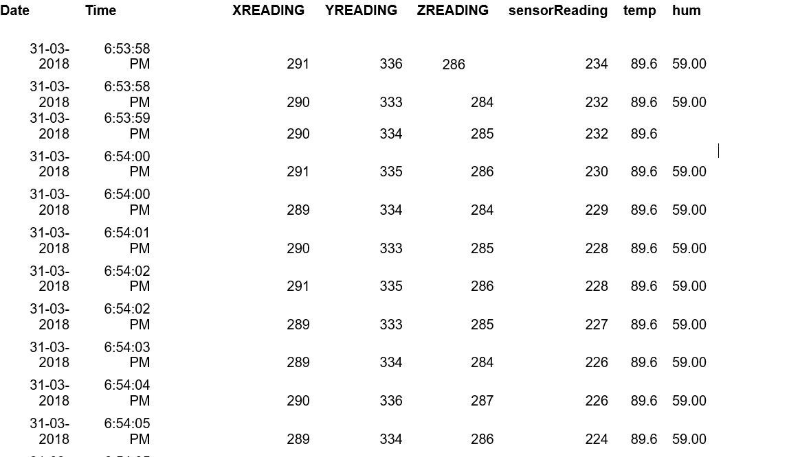

**8.2 APPLYING REGRESSION AND PREDICTION**

Keeping the dependent Sensor reading and temperature, X reading, Y reading, Z reading as independent variables multiple regressions is applied using linear model function and stored in a particular variable. Using the predict function the Sensor reading value for the particular temperature and humidity can be predicted easily.

This application imports in a company data set with multiple fields where Date, Time, Sensor reading, temperature, humidity are taken in for further proceedings for the time being. The data for linear model function are given by importing the data set and specifying the column names along with the name of the data set. The data set should be in the format of CSV (Comma Separated Values).

Also the data set for the next interval is available, therefore the result obtained using the prediction and the actual result can be cross verified and the accuracy can be measured.

**CHAPTER 9**

**CONCLUSION AND FUTURE ENHANCEMENTS**

**9.1 CONCLUSION**

The condition and working of the machine along with the prediction of the lifetime of the machinery are analysed in the proposed system. The implementation of predictive analysis which uses linear regression algorithms is done and the lifetime is predicted to an accurate rate .The fault occurring conditions are identified in the earlier stages itself and changes are analysed and then prediction is implemented. The health of the machine is monitored in the automated world without interrupting the general working of machineries successfully.

**CHAPTER 10**

**APPENDIX**

**10.1 SOURCE CODE**

**ARDUINO CODE:**

#include <DHT.h>

#define DHTPIN 2

#define DHTTYPE DHT11

DHT dht(DHTPIN, DHTTYPE);

float hum;

float temp;

int groundpin;

int powerpin;

const int xpin = A0;

const int ypin = A1;

const int zpin = A2;

int sensorReading = 0;

int ledState = LOW;

const int knockSensor = A3;

const int threshold = 100;

const String XREADING = "X: ";

const String YREADING = "Y: ";

const String ZREADING = "Z: ";

const String TAB = "\t";

float converted = 0.00;

void setup()

{

Serial.begin(9600);

Serial.println("CLEARSHEET");

pinMode(groundpin, OUTPUT);

pinMode(powerpin, OUTPUT);

digitalWrite(groundpin, LOW);

digitalWrite(powerpin, HIGH);

dht.begin();

Serial.println("LABEL,Date,Time,blank,XREADING,YREADING,ZREADING,sensorReading,temp,

hum");

}

void loop()

{

sensorReading = analogRead(knockSensor);

hum = dht.readHumidity();

temp= dht.readTemperature();

converted = ( temp * 1.8 ) + 32;

Serial.print("DATA,DATE,TIME,");

Serial.print(",");

Serial.print(analogRead(xpin));

Serial.print(",");

Serial.print(analogRead(ypin));

Serial.print(",");

Serial.print(analogRead(zpin));

Serial.print(",");

Serial.print(sensorReading);

Serial.print(",");

Serial.print(converted);

Serial.print(",");

Serial.print(hum);

Serial.println("\n");

delay(600);

}

**RStudio CODE:**

mo=read.csv(choose.files())

key=data.frame(val=800)

fit=lm(temp ~ val,mo)

predict(fit,key)

ki=subset.data.frame(mo$sensorReading>800)

predict(fit)

newcar = data.frame(sensorReading=450)

predict(fit, newcar)

require(ggplot2)

ggplot(mo,mapping = aes(mo$sensorReading,mo$temp))+geom_point()+geom_smooth(method="lm")

##for multiple linear Regression

mfit = lm(sensorReading ~ Time + temp + hum, data=mo)

mfit = lm(mpg ~ wt + disp + cyl, data=mtcars)

ggplot(mo, aes(x=mo$Time, y=mo$sensorReading, col=mo$temp, size=mo$hum))

+ geom_point()

**10.2 SCREENSHOTS**

**Dynamic data set acquisition**

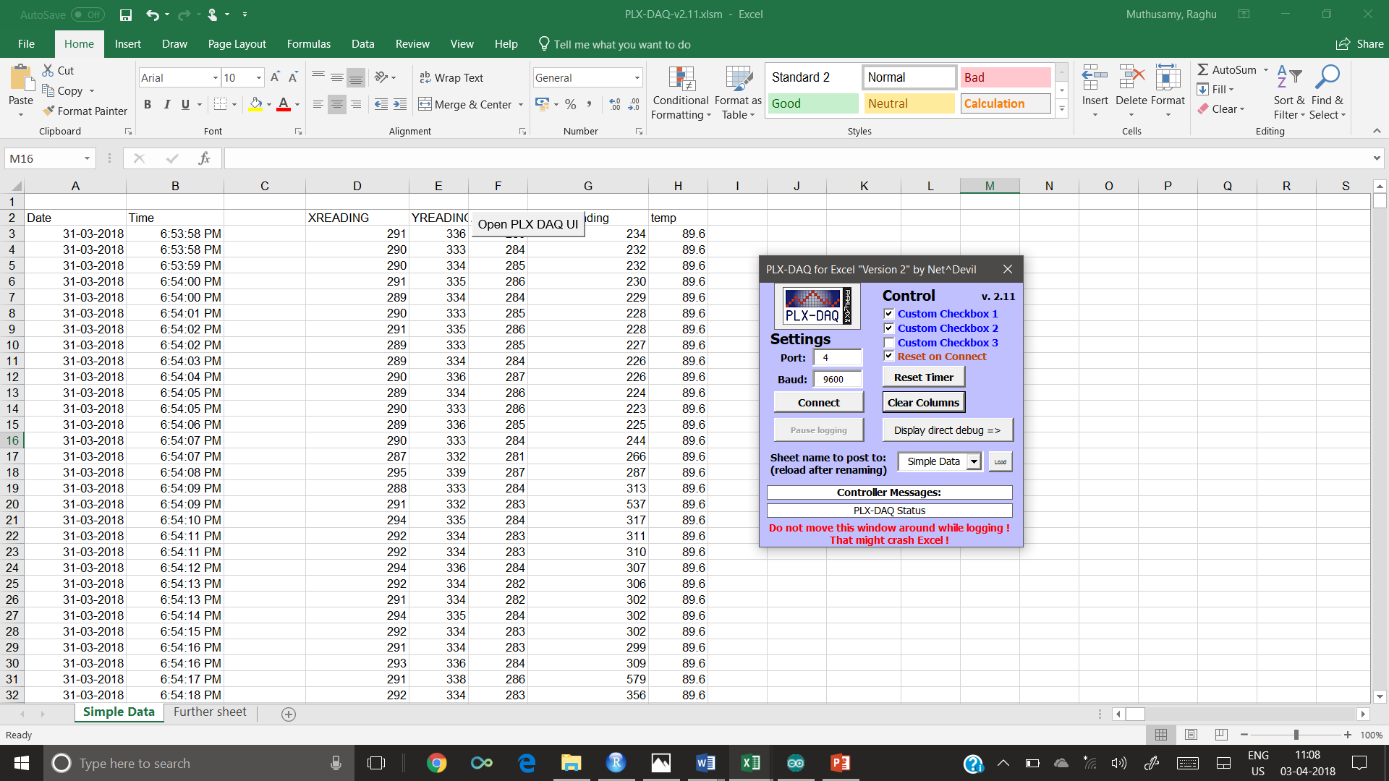

**Linear graph implementation**

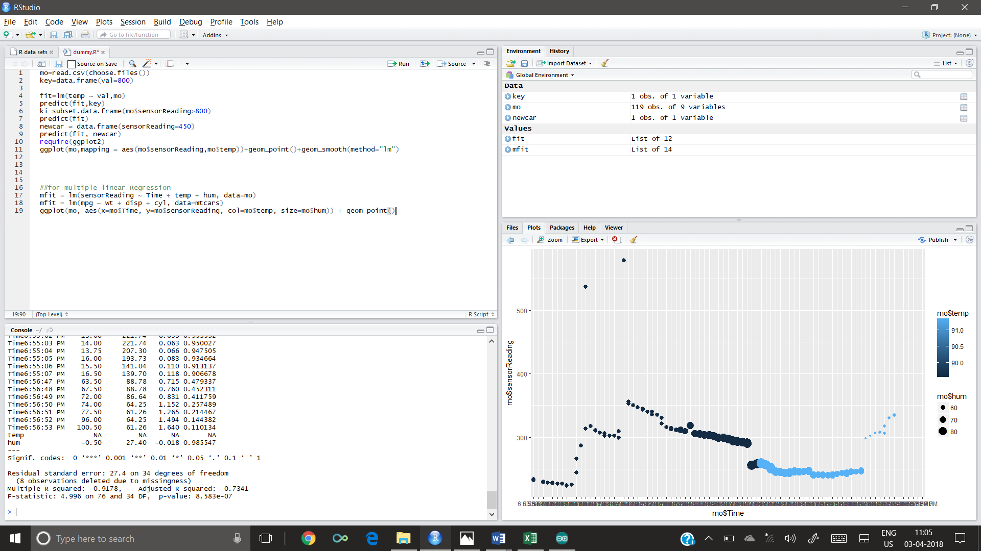

10.3 REFERENCE

[1] Vladimir Dekys Condition monitoring and fault diagnosis2017XXI International Polish-Slovak Conference “Machine Modeling and Simulations 2016” vol. no:177 pp:502-509

[2] Joel Igba , Kazem Alemzadeh , Christopher Durugbo , Egill Thor Eiriksson “Analyzing RMS and peak values of vibration signals for condition monitoring of wind turbine gearboxes 2016” vol. no:46 pp:155-160

[3] Sebastian Bombinski, Krzysztof Blazejak, Miroslaw Nejman Krzysztof Jemielniaka, “Sensor signal segmentation for tool condition monitoring**,**Warsaw University of Technology, Narbutta 86, 02-524 Warsaw, Poland 2016” vol.no:91 pp:90-106

[4] B. Myhrea,S. Petersen, R. Ugarelli  **“**Using Wireless Vibration Monitoring to Enable Condition-Based Maintenance of Rotating Machinery in the Water and Wastewater Industries ,16th Conference on Water Distribution System Analysis, WDSA 2014” vol. no:89 pp:1397-1403